**MongoDB Queries Task**

1. **Find all the information about each product**

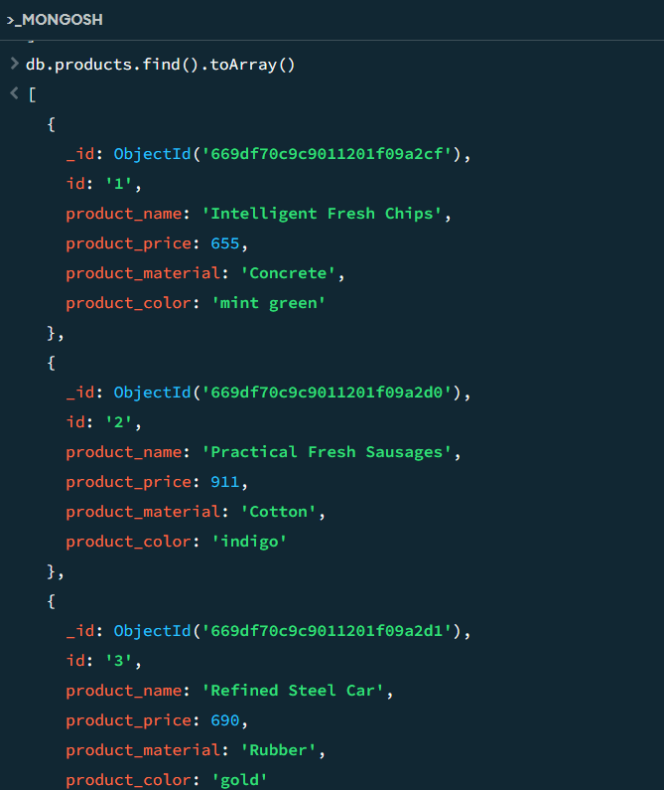

1. **Find the product price which are between 400 to 800**

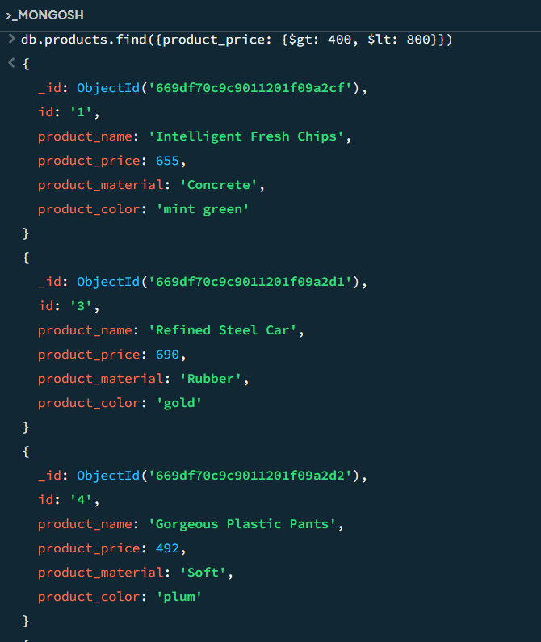

1. **Find the product price which are not between 400 to 600**

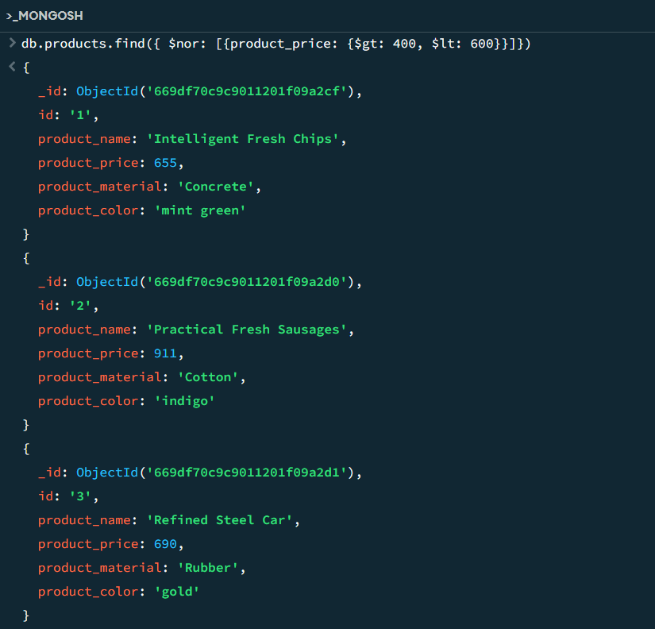

1. **List the four product which are greater than 500 in price**

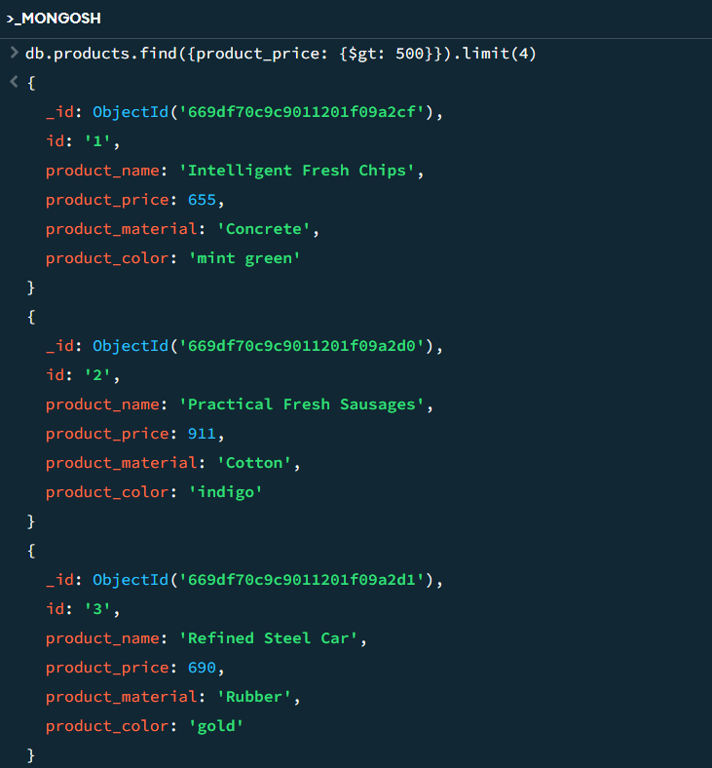

1. **Find the product name and product material of each products**

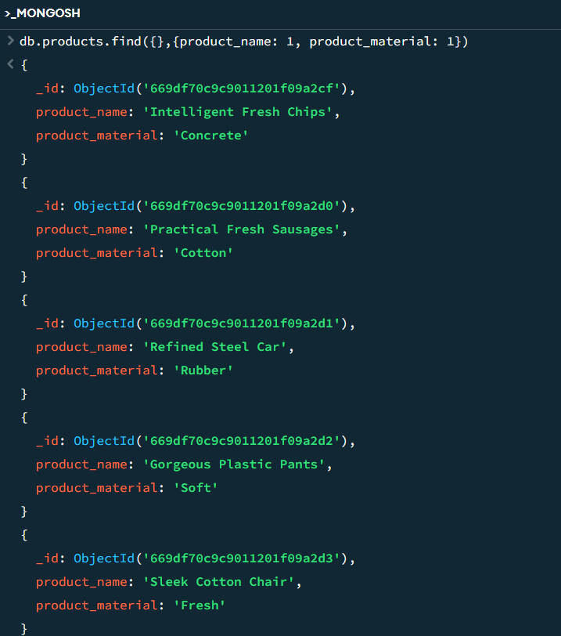

1. 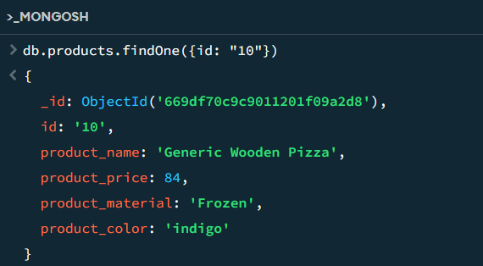**Find the product with a row id of 10**
2. **Find only the product name and product material**

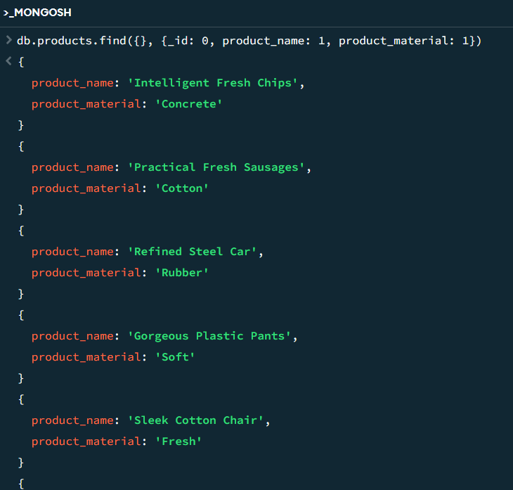

1. **Find all products which contain the value of soft in product material**

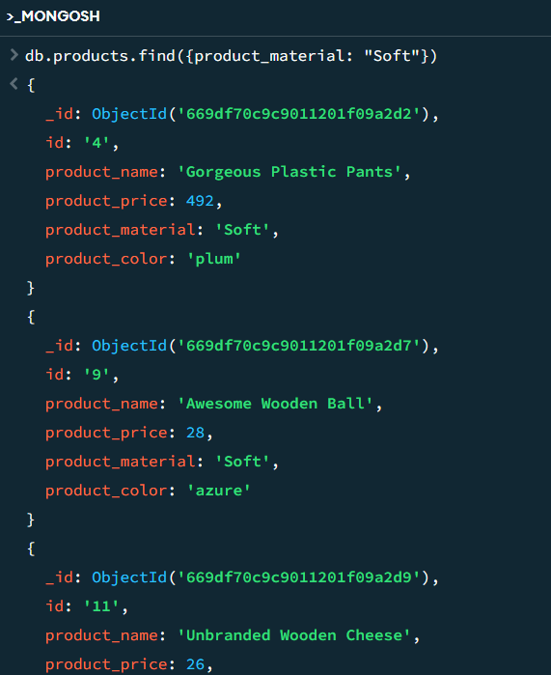

1. **Find products which contain product colour indigo and product price 492.00**
   * 1. **Both condition matches (no products)**



* + 1. **Either one condition matches**

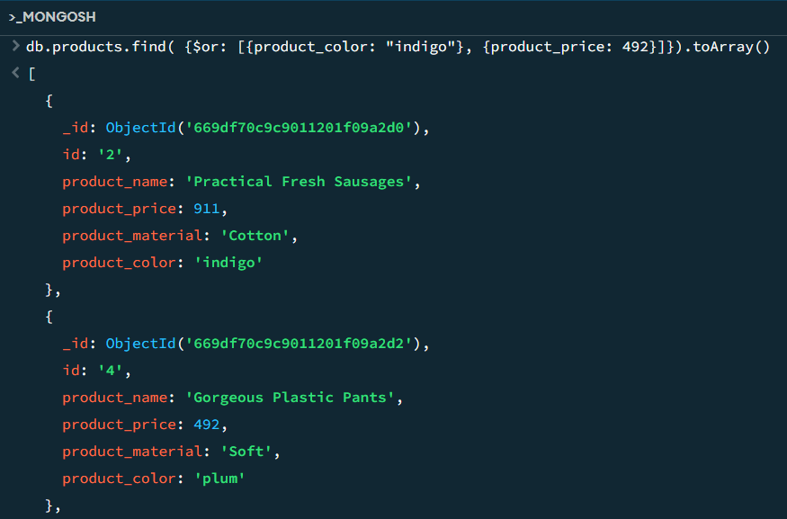

1. **Delete the products which product price value are 28**
   * 1. **Only one product matches the price value 28 ( id: 9 )**

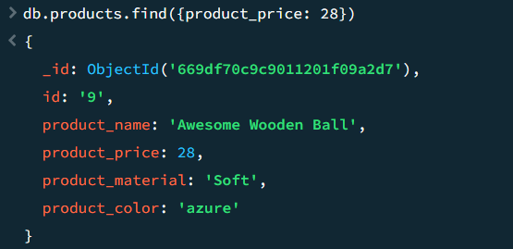

* + 1. **Deleted all the products which product price value matches 28**

